A
Case Report
on
PROCESS PLANNING FOR A MANUFACTURED COMPONENT
Submitted by
Chavan Deepak Balu
Under the Guidance of
Prof. Y.L. Suryavanshi
In partial fulfilment of
B.Tech. in
(Electronics & Telecommunications Engineering)
DR. BABASAHEB AMBEDKAR TECHNOLOGICAL UNIVERSITY,
LONERE (M.S.)

Marathwada Shikshan Prasarak Mandal’s
Deogiri Institute of Engineering & Management Studies,
Chhatrapati Sambhajinagar.
Department of Electronics & Telecommunications Engineering,
Maharashtra, India.
2026-27

CONTENTS
SR.NO. | TOPIC | PAGE NO.
1. | INTRODUCTION
 | 1.1 Introduction
2. | BACKGROUND
 | 2.1 Problem Statement
3. | OBJECTIVES
 | 3.1 Objectives and Success Criteria
4. | METHODOLOGY / APPROACH
 | 4.1 Process Planning Method
5. | IMPLEMENTATION
 | 5.1 Detailed Process Plan
6. | CONCLUSION AND FUTURE SCOPE
 | 6.1 Conclusion and Future Scope

1. Introduction
1.1 Introduction
Process planning is the organised method used to convert a component drawing into a complete manufacturing route. It answers practical questions before production begins: which raw material will be used, which dimensions must be made first, which machine and tool are suitable, how the component will be held, and how the finished part will be inspected. A technically correct drawing alone does not guarantee that a part can be manufactured repeatedly. The route plan provides the link between the design office and the workshop.
This case study considers a machined flanged hub used in a shaft coupling. The hub carries torque through a parallel key and joins to a mating flange through six threaded holes. Its main features are a stepped outside diameter, a flange face, a 30 H7 through bore, an 8 mm keyway and a six-hole bolt circle. Since the part contains both rotational and non-rotational features, it is a useful example for explaining the relationship between turning, milling, drilling and inspection operations.
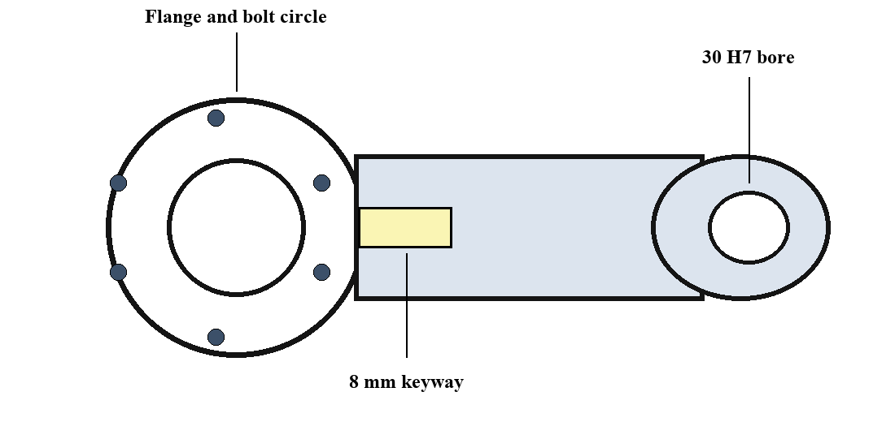
The purpose of the study is to prepare a practical process plan for batch manufacture. The route begins with steel bar stock and ends with a cleaned, inspected and protected component. The planning decisions are made to achieve dimensional accuracy, reduce the number of set-ups, control production cost and avoid common workshop defects such as eccentricity, burrs, incorrect keyway depth and misplaced holes.
The plan is written for a small or medium engineering workshop with a CNC lathe, a vertical machining centre, normal measuring instruments and a trained production team. The dimensions and times used in the case are representative. In actual manufacture, the approved engineering drawing, material specification and inspection plan must always take priority over the illustrative values in this report.

2. Background
2.1 Problem Statement
The flanged hub has to perform two important functions. First, its finished bore must fit the shaft with the specified clearance or interference condition. Second, its flange, keyway and mounting holes must transmit torque and assemble correctly with the connected parts. These requirements make the relationship between the bore, outside diameter and flange face especially important. A small error in one early operation can create an alignment problem that is difficult or expensive to correct later.
A common manufacturing problem is loss of concentricity between the bore and the turned outside diameter. If the bore is machined in a separate, poorly located set-up, the hub can run out when fitted on the shaft. Another concern is the position of the keyway. A keyway made from an unfinished reference surface may not align accurately with the shaft axis. Similarly, an incorrectly located bolt circle can prevent the flange from assembling with its mating part.
The selected material is normalized EN8/C45 steel supplied as 90 mm diameter round bar. The component is assumed to have a finished flange outside diameter of 84 mm, a hub outside diameter of 56 mm, an overall length of 78 mm, a 30 H7 bore, an 8 mm wide keyway and six M8 threaded holes on a 68 mm pitch circle diameter. The production requirement is 12,000 parts per year, produced in batches of 250.
The process-planning problem is therefore to create a route that produces these features with dependable accuracy. The plan must define the order of work, the datums, the machines, the tools and the checks. It should also minimise handling and allow the workshop to identify and correct a problem during the batch rather than after all parts have been completed.
The background analysis also shows why process planning must balance quality with production economy. A route with too many separate set-ups increases handling time and creates more opportunities for location error. A route with too little inspection may produce a complete batch of defective parts before the problem is detected. The preferred plan therefore uses the minimum number of accurate set-ups, clear workholding and measurement at the features that are most important to the assembly.

3. Objectives
3.1 Objectives and Success Criteria
The first objective is to select a logical manufacturing sequence. The route should move from raw stock through rough machining, finishing, secondary operations and inspection without reversing the natural order of work. Heavy metal removal must be completed before precision finishing so that later cuts are not disturbed by distortion, chucking marks or handling damage.
The second objective is to establish functional datums. Datum A is the finished flange face and Datum B is the finished bore axis. These are chosen because they control the way the hub seats against the mating flange and locates on the shaft. Turning the flange face, hub diameters and bore in one lathe set-up helps maintain the relationship between these features. The finished bore can then locate the component on an expanding mandrel for milling and drilling.
The third objective is to specify workable resources. The plan identifies a band saw for preparing blanks, a CNC lathe for facing, turning and boring, and a vertical machining centre for the keyway and bolt circle. It also identifies suitable tooling, including roughing inserts, a boring bar, a reamer, an 8 mm end mill, drills, taps and measuring gauges. This prevents uncertainty at the machine and supports repeatable set-up.
Success is achieved when the bore meets 30 H7, bore-to-outside-diameter runout is not greater than 0.03 mm, the keyway and holes are correctly located, threaded holes pass the plug gauge and all edges are free from burrs. The batch must also have first-off approval, in-process checks and final inspection records to provide traceability.
The objectives are linked to measurable production outcomes. A clear route sheet reduces variation between operators, the datum scheme controls the critical geometry, and the inspection plan provides evidence that the component meets the drawing. Together, these controls support predictable lead time, lower rejection and a component that can be assembled without unnecessary fitting work.

4. Methodology / Approach
4.1 Process Planning Method
The process-planning method begins with a detailed review of the component drawing. The planner identifies the material, shape, dimensions, tolerances, surface-finish requirements and functional features. The bore, flange face, keyway and bolt circle are marked as critical features because they influence fitting and torque transmission. The planner then chooses the starting material and provides enough machining allowance for facing and turning without wasting excessive stock.
The next step is to decide the datum sequence. The saw-cut surface is not accurate enough to be a permanent datum, so the first lathe operation creates a clean flange face. This finished face becomes Datum A. The bore is then drilled, bored and finished in the same lathe set-up as the turned diameters. This establishes Datum B, the bore axis. Keeping these operations in one chucking reduces concentricity error and avoids the need to re-establish the relationship between the shaft fit and outside surfaces.
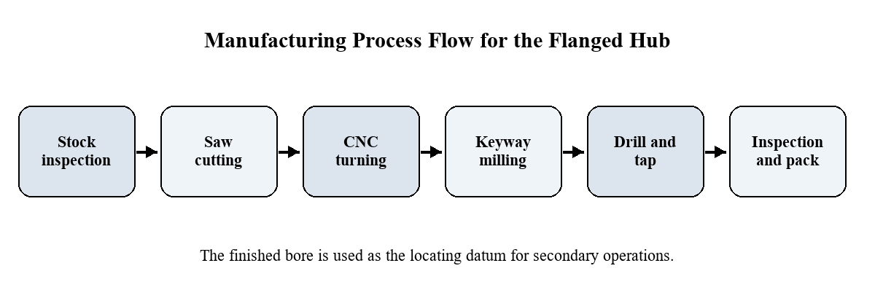
After turning, the component is located through the finished bore on an expanding mandrel in the vertical machining centre. This fixture gives positive axial and radial location. The keyway is milled before the bolt-circle holes are drilled and tapped. The final stage includes deburring, washing, inspection, rust prevention and packing. This order protects the finished surfaces and prevents chips or burrs from remaining in the bore or threads.
Production data are collected from the approved drawing, material certificate, machine capability records, tool catalogues, gauge availability and planned batch quantity. During the first-off trial, the operator measures the critical dimensions and the planner adjusts offsets, tooling or fixturing if required. The approved route sheet then becomes the standard instruction for the remaining parts in the batch.

5. Implementation
5.1 Detailed Process Plan
Implementation starts with material receipt and identification. The steel bar is checked against the material certificate, diameter requirement and visual condition. It is then cut on an automatic band saw to 95 mm, allowing sufficient stock for facing. Each blank is associated with the batch number so that material, machining and inspection records can be traced throughout production.
In operation 30, the blank is clamped in the CNC lathe. The first end is faced to create a clean reference surface, and the outside diameter is rough turned. A pilot hole is drilled to prepare for boring. In operation 40, the same set-up is used to finish the flange face, the external diameters, the overall length and the 30 H7 bore. A boring bar and reamer are selected according to the required finish and tolerance. A light chamfer removes sharp edges at the bore and flange face.
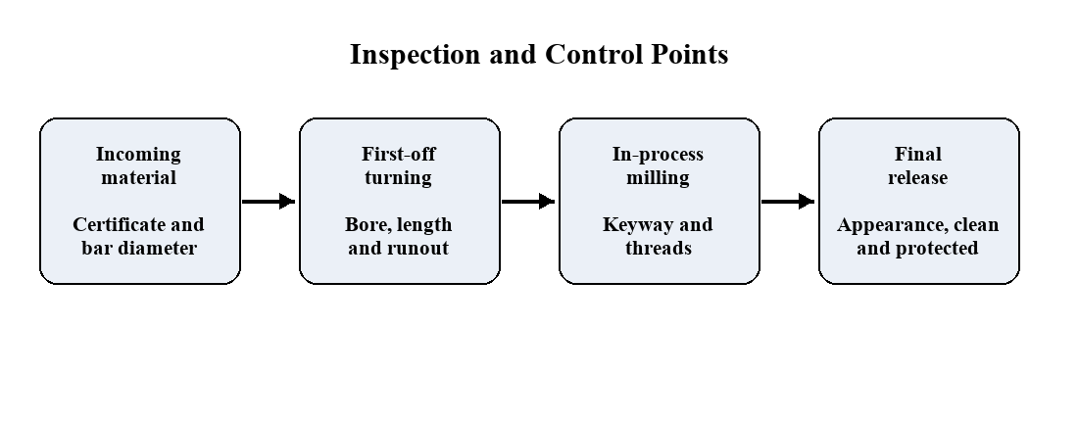
For the secondary operations, the finished bore is placed on an expanding mandrel in the vertical machining centre. The mandrel uses the functional bore as the locating feature and the flange face as the axial seating surface. The 8 mm keyway is milled to the specified width and depth. The machine program then positions the part at six equal angular locations, where it spot drills, drills 6.8 mm holes and taps M8 threads on the 68 mm pitch circle diameter.
The final operations remove burrs, wash the component and inspect it. The first-off part is checked for bore size, runout, overall length, keyway width and depth, bolt-circle position and thread quality. During the batch, keyway and thread gauges are used at planned intervals. Finished hubs are coated with rust preventive, packed with protective material and released only after final inspection approval.

6. Conclusion and Future Scope
6.1 Conclusion
This case study shows how a manufactured component can be planned from raw material to final inspection. The flanged hub is a suitable example because its performance depends on the relationship between turning, boring, milling and drilling operations. The resulting process plan is not simply a list of machine operations; it is a controlled sequence built around the functional requirements of the component.
The key planning decision is to create the finished flange face and bore early in the route. These surfaces become the primary datums for the remaining work. Completing the external diameters and bore in one CNC-lathe set-up controls concentricity. Locating the part through its finished bore on an expanding mandrel controls the position of the keyway and bolt circle. This approach reduces the chance of accumulated location errors and makes the route easier for an operator to follow.
The case also demonstrates the importance of inspection within the process rather than only at the end. Incoming material checks prevent unsuitable stock from entering production. First-off inspection confirms that the tools, offsets and fixture are correct. In-process checks on the keyway, bore and threads prevent a defect from continuing through the whole batch. Final inspection, cleaning and corrosion protection ensure that the component reaches assembly in an acceptable condition.
Future improvement can include bar-fed turning, in-machine probing, automatic part handling and a dedicated hydraulic fixture for higher volumes. Statistical process control can be introduced for the bore and runout once a stable capability level is established. A digital route sheet connected to tool-life, machine and inspection records would further improve traceability and support continuous improvement in cost, quality and delivery.

